How to alter the configuration file rhinoview.csv

Background
There are hundreds of different Suzuki ECUs in a good number of different models of different years all around the world. Different ECUs can return different values from the same addresses. To make Rhinoview a universal piece of software a mechanism must be used to enable the software to know what function is at each address for any ECU, I have chosen to use a text file that I refer to as the ‘configuration file’.

The configuration file is a .csv file, this is a file type that harks back to the very early days of computer communications. The file contains data fields separated by commas with each line terminated by a New Line character and a carriage Return, files of this type are most easily edited using a spreadsheet tool such as Excel.

Function Numbering
Each function is assigned a function number as shown in the screen shot below. For example the Vehicle Speed Sensor is Function 6.:

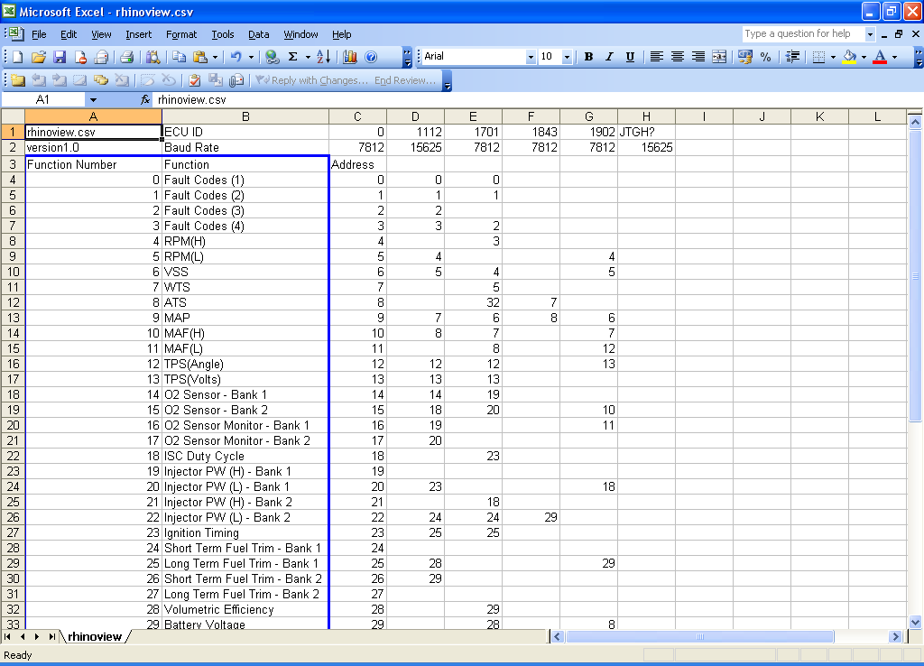

ECU Identification Numbers
Each ECU has its own embedded Identification String, this ID string is returned by the ECU and displayed in the status bar on the main page of Rhinoview.

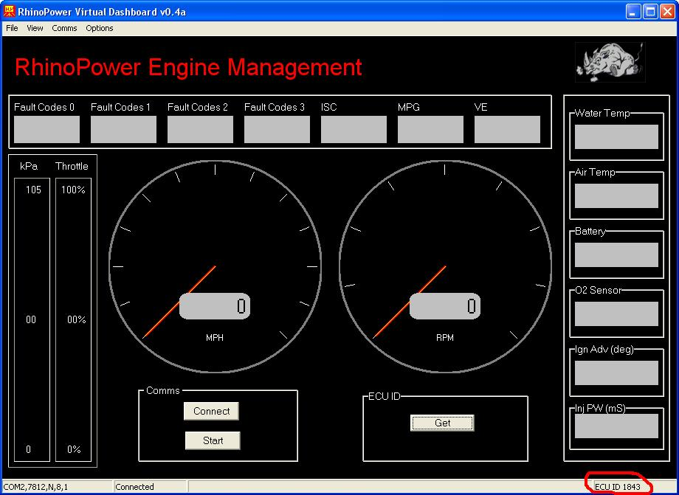

Data for each ECU is stored in columns with the ECUID at the top of each column. New ECU IDs can be added by adding a new column with the ID number at the top. On the line below this the Baud rate should be entered.

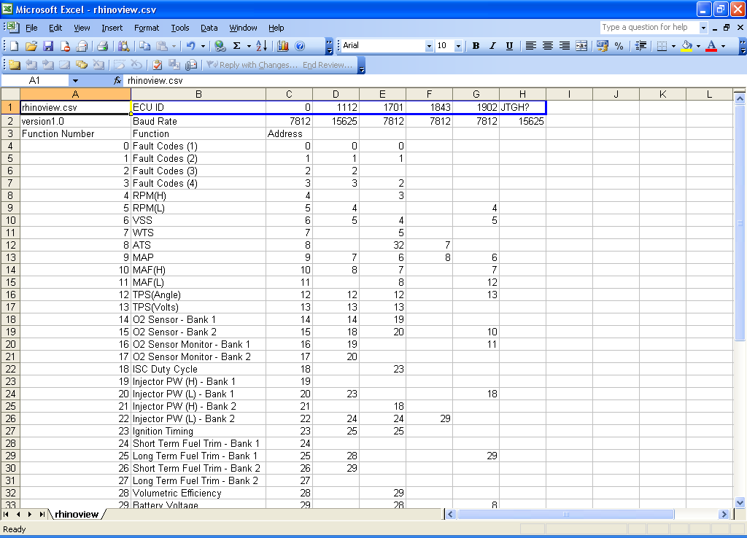
Address Mapping
Referring to the screen capture below, column C contains the address, for each address the function number for that address should be filled in. If the address is not known then the cell can be left blank. Future versions of Rhinoview will use selective address polling, for addresses that are unused or out of range enter “none”, these addresses will not be polled, this will allow much faster polling of the remaining addresses.

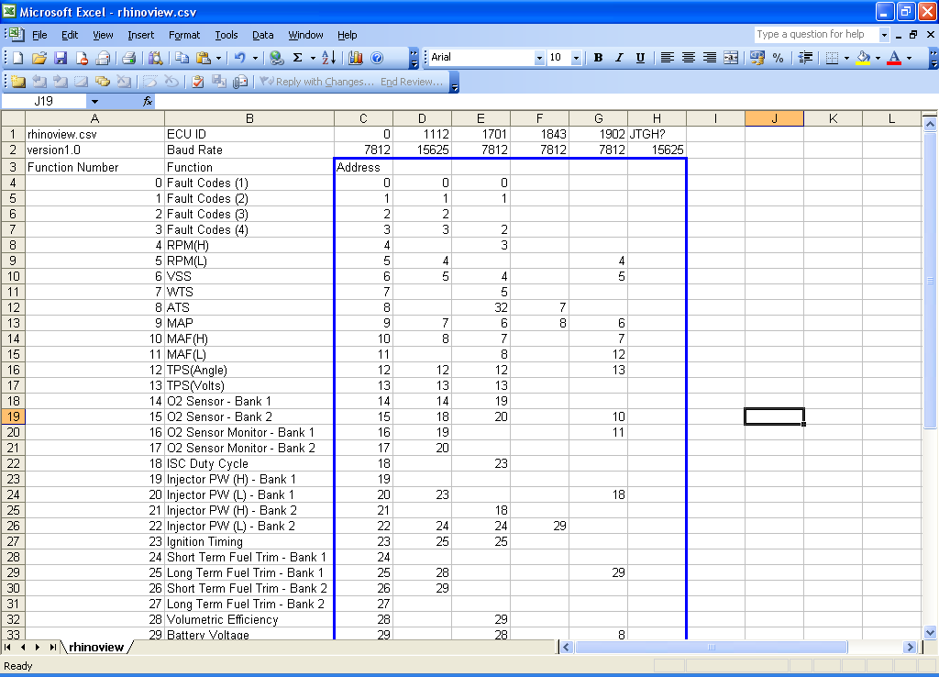

ECU ID 0000

ECU ID 0000 is a special case, this is provided for debugging and address hacking and is intended for use with the Dataviewer and , in future releases, with the datalogger. Selecting this ID will removing any address remapping so, for example, address 5 will be displayed at location 5. The ECU ID number can be selected from the main menu Options->ECU.
Note that editing the config. File with Excel will cause the leading zeros to be removed so an error message will be displayed warning that the ECU is not supported. The addressing will be correct, this is caused by Excel removing the leading zeroes, if necessary this can be fixed by editing the first line of the config. file in a text editor such as Notepad, as shown below:

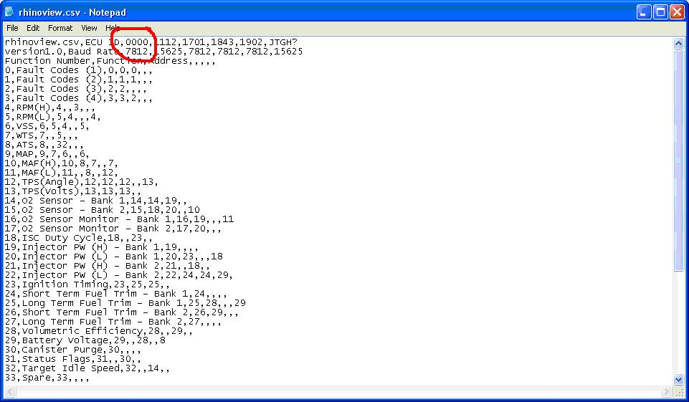

Constant Values

There are a number of scaling factors that must be completed to ensure that Rhinoview functions correctly, these are including under constants. The value is the number that the data returned by the ECU must be multiplied by to give the correct reading.

For Example: At 1000rpm a 1112 ECU returns a value of 250. The scaling factor is therefore 4 so 250 * 4 = 1000.

RPM is engine speed in revs per minute.

VSS is Vehicle Speed Sensor, note that VSS returns a value in km/h.

INJPW is Injector Pulsewidth.

INJFLOW is injector flowrate is in cc/min and is included to enable fuel consumption to be calculated. This value will need to be adjusted to compensate for tolerances in injector flow rates, fuel pressure and tyre size/wear. It is not intended to be considered an absolute value but can be used to compare relative mpg during different driving conditions. Currently MPG is only displayed in Imperial Gallons, US gallons and L/kmh will be added to a future release.

