Rhinoview Help

1 Installing Rhinoview 4
1.1 Overview 4
1.2 To add to the program menu in Windows 7: 4
2 Serial Port Set Up 4
3 Connecting to the ECU 5
4 The Dashboard 6
4.1 MIL Indication 6
4.2 Menu Functions 6
4.2.1 File 6
4.2.2 View 6
4.2.3 Comms 6
4.2.4 Options 7
4.2.5 Commands 7
5 The Data Viewer 9
5.1 Menu 9
5.1.1 File 9
6 Data Logger 10
7 Fault Code Viewer 11
8 GENERAL PARAMETERS 12
8.1 CALC LOAD 12
8.2 CHARGING EFFICIENCY 12
8.3 ECT SENSOR VOLTAGE 12
8.4 ENGINE COOLANT TEMPERATURE 12
8.5 ENGINE LOAD 12
8.6 ENGINE SPEED 12
8.7 FUEL TEMPERATURE 12
8.8 VEHICLE SPEED 12
9 ELECTRICAL PARAMETERS 13
9.1 BATTERY VOLTAGE 13
9.2 ELECTRIC LOAD 13
10 SPARK CONTROL PARAMETERS 13
10.1 IGNITION ADVANCE 13
10.2 IGNITION TIMING LEVEL 13
10.3 SPARK ADVANCE SWITCH 13
11 FUEL DELIVERY PARAMETERS 14
11.1 AIR FLOW 14
11.2 BAROMETRIC PRESSURE 14
11.3 BAROMETRIC SENSOR VOLTAGE 14
11.4 EGR THROTTLE 14
11.5 FUEL CUT 14
11.6 FUEL PRESSURE CONTROL VALVE 14
11.7 FUEL PUMP 14
11.8 FUEL RAIL PRESSURE 14
11.9 FUEL SYSTEM STATUS 14
11.9.1 FUEL SYSTEM B1 14
11.9.2 FUEL SYSTEM B2 14
11.10 FUEL TANK LEVEL 14
11.11 INJECTOR FLOW 15
11.11.1 INJECTOR FLOW 1 15
11.11.2 INJECTOR FLOW 2 15
11.11.3 INJECTOR FLOW 3 15
11.11.4 INJECTOR FLOW 4 15
11.12 INJECTOR PULSE WIDTH 15
11.12.1 INJECTOR PULSE WIDTH B1 15
11.13 INTAKE AIR TEMPERATURE 15
11.14 LONG FT B1 B1: BANK 1 (LH BANK) 15
11.15 LONG FT B2 B2: BANK 2 (RH BANK) 15
11.16 MANIFOLD ABSOLUTE PRESSURE (MAP) 15
11.17 MASS AIR FLOW (MAF) 15
11.18 MIXTURE CONTROL DWELL B1 & B2 15
11.18.1 B1:BANK1 (LH BANK) 15
11.18.2 B2:BANK2 (RH BANK) 15
11.19 MIXTURE CONTROL LEARN 16
11.19.1 MIXTURE CONTROL LEARN B1 & B2 16
11.19.2 B1:BANK1 (LH BANK) 16
11.19.3 B2:BANK2 (RH BANK) 16
11.20 MIXTURE CONTROL MONITOR 16
11.20.1 MIXTURE CONTROL MONITOR B1 & B2 16
11.20.2 B1:BANK1 (LH BANK) 16
11.20.3 B2:BANK2 (RH BANK) 16
11.21 NEEDLE SENSOR VOLTAGE 16
11.22 O2S ACTIVATION 16
11.22.1 O2S B1 ACTIVATION 16
11.22.2 O2S B2 ACTIVATION 16
11.23 O2S SIGNAL 16
11.23.1 B1:BANK1 (LH BANK) 16
11.23.2 B2:BANK2 (RH BANK) 16
11.23.3 O2S O2S B1 S1 17
11.23.4 B1:BANK1 (LH BANK) 17
11.23.5 B2:BANK2 (RH BANK) 17
11.24 PEDAL POS SENSOR 17
11.25 RAIL PRESSURE REGULATOR 17
11.26 RICH/LEAN MONITOR 17
11.26.1 RICH/LEAN MONITOR B1 17
11.26.2 RICH/LEAN MONITOR B2 17
11.26.3 B1:BANK1 (LH BANK) 17
11.26.4 B2:BANK2 (RH BANK) 17
11.27 SHORT FT B1 B1: BANK 1 (LH BANK) 17
11.28 SHORT FT B2 B2: BANK 2 (RH BANK) 17
11.29 START OF INJECTION 18
11.30 THROTTLE ANGLE 18
11.31 THROTTLE OPENER SOLENOID 18
11.32 THROTTLE POSITION 18
11.32.1 THROTTLE POSITION SENSOR 18
11.32.2 TP SENSOR VOLT 18
11.33 TURBO PRESSURE 18
12 EMISSIONS AND DRIVEABILITY PARAMETERS 19
12.1 CANISTER PURGE SOLENOID 19
12.2 CANISTER PURGE DUTY 19
12.3 CLOSED THROTTLE POSITION 19
12.4 CTP SWITCH 19
12.5 DESIRED IDLE SPEED 19
12.6 EGR 19
12.6.1 EGR VALVE 19
12.6.2 EGR TEMPERATURE 19
12.7 EVAP CANIST 19
12.7.1 EVAP PURGE DUTY 20
13 Summary of Fault Codes 25

Installing Rhinoview

Overview
Rhinoview is an old-fashioned standalone programme and requires no installation programme. To install create a folder wherever you like and unzip RV to that folder.
To create a shortcut right click on the Rhinoview icon and select ‘Create Shortcut’, the shortcut can then be cut and pasted or dragged to any location.

To add to the program menu in Windows 7:

There are a number of methods that can be used to achieve this, this Help describes just one of these techniques.
Navigate to the folder in which you installed Rhinoview. Rhight Click on the Rhinoview icon and click ‘Copy’.
Click on the Start icon and in the Run box type ‘shell:common start menu’

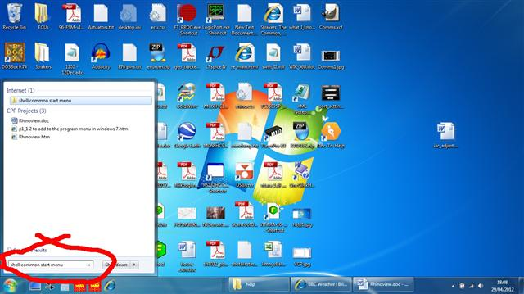

In the Program folder right click and select ‘Paste’.

Serial Port Set Up
The RhinoPower SDL interface implements a Virtual Com Port. The FTDI VCP drivers must be installed before connecting the interface to the USB port.
The Windows device manager can be used to determine the Com Port number:

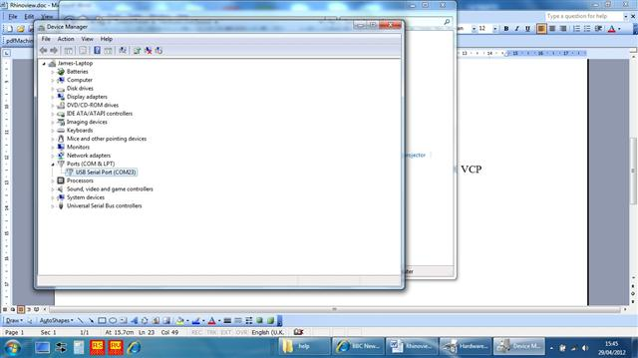

Start Rhinoview and select ‘Comms’ then ‘Settings’, the Comms setup window will be displayed:

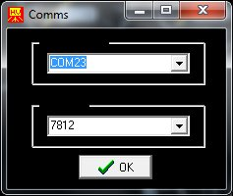

The Baud Rate and Com Port can also be typed in; any valid Com Port number can be used.
Com port settings are automatically loaded when the programme starts and are saved when the programme exits.

Connecting to the ECU
The SDL Interface sources power from the Vehicle so the ignition switch must be turned on.
Plug the SDL interface into the J1962 socket on the vehicle and plug the USB cable into the laptop.
Turn on the ignition
Start Rhinoview and, if required, set up the comms port.
From the menu bar select ‘Comms’ and then ‘Connect’
Rhinoview will display ‘Connected’ when connected to the SDL interface. When connected to the ECU the ECU ID number will be displayed on the right hand side of the status bar in the Dashboard window. If the baud rate has to be changed when RV shows ‘Connected’ the programme must be closed and reopened.

The Dashboard

The dashboard is the main window and must be open when using Rhinoview, closing this window closes the programme; this is the only window that must be left open.

MIL Indication
The MIL indicator will display the text ‘MIL’ in black if there are no fault codes, yellow if there are stored codes and red if there are current codes. Clicking on the MIL indicator will bring up the Fault Code Viewer.

Menu Functions

File

Exit
Closes the programme.

View

Data Viewer
Opens the DataViewer window. This window displays data from the ECU either formatted in relevant units or as raw data in hex format.

Data Logger
Opens the Data Logger window. The datalogger allows up to four parameters to be logged and saved to a file.

Fault Codes
Opens the FaultCode Viewer window. This window displays both current fault codes and stored fault codes.

Status Flags
Opens the StatusViewer window. This window displays the current state of any status flags that are reported by the ECU.

Comms

Connect
Opens a vitual com port and connects to the SDL interface

Settings
Opens a window for modifying the Com Port settings; settings are automatically saved when the programme exits

Sample Rate
The sample rate sets the interval at which Rhinoview sends a data request to the ECU. The recommended setting is 100ms, although some ECUs will be able to poll faster. The status bar displays a value for ‘Bad data’ which is the number of messages that have not been replied to by the ECU. Bad data should usually be around zero - if the value increases continuously then either the connection has failed or the sample rate value is too low.
The sample rate is not the interval at which data is received from the ECU, the response time from the ECU will vary dependant on processor loading. Rhinoview requests four data bytes at a time although some values, such as RPM, are two bytes long, there will also be several status flags in one status byte. Overall the data rate will be a little faster than four times the sample rate.
Sample rate is automatically saved on programme exit and reloaded on programme start.

Options

Units
Opens the units selection window. This window allows the user to choose to display vehicle speed in MPH or KM/H and temperature in Celsius or Fahrenheit.

Commands
This menu allows various commands to be sent to the ECU, not all commands will be valid for any particular ECU. - the Factory Service Manual for the vehicle should be referred to.

Request ID
Send an ID request to the ECU, the ECU will return its ECU ID which is displayed on the Dashboard, in the status bar. This is a deprecated function and has no real use.

Reset ECU
Send a reset request to the ECU. This command clears the fault codes and any learned values.

RPM Control
Open the Controls window. The idle speed can be set by Rhinoview to check that the Idle Speed Controller functions correctly.

Fix Advance
Fixes the Spark Advance to allow the ignition timing to be check or set.

IAC Calibration
Open the Controls window. IAC Calibration mode is used to check or set the idle adjuster setting.

EGR Solenoid Control
Open the Controls window. The EGR valve can be opened and closed to test for correct operation. When opened idle speed can be expected to drop to approx. 400 RPM if the EGR is functioning correctly.

EGT Stepper Control
Open the Controls window. The EGR valve can be opened and closed to test for correct operation. When fully opened idle speed can be expected to drop to approx. 400 RPM if the EGR is functioning correctly.

Rad. Fan Control
Open the Controls window. The radiator fan can be turned on or off to check for correct operation of the fan and its control circuitry and wiring.

Can. Purge Solenoid Control
Open the Controls window. The Evap. Canister Purge Solenoid can be opened or closed to check for correct operation of the solenoid and its control circuitry and wiring.

Fuel Pump Control
Open the Controls window. The fuel pump can be opened or closed to check for correct operation of the pump and its control circuitry and wiring.

The Data Viewer
When viewing formatted data the data is arranged so that the main functions are displayed on the first page. The second page contains the remaining functions including those specific to the second bank on a V6 engine.

When viewing Raw Data the data is displayed at the address from which it is returned by the ECU.

Menu

File

Close
Closes the Data Viewer window.

Exit
Closes the Data Viewer window and exits the programme.

Data Logger
The data logger allows up to four channels of data to be logged at a time.

Values from the ECU are stored in a buffer, the timestamp gives the time at which the buffer was polled. There may therefore be a small time lag between an event happening and that event being logged.
The maximum time delay will depend on the number of addresses being polled, the sample interval and the datalogger timebase setting.

Fault Code Viewer
The Fault Code viewer displays current fault codes and stored fault codes.

GENERAL PARAMETERS

CALC LOAD
Calc Load is engine load displayed as a percentage. Its value is calculated mathematically using the
following formula:
actual (current) intake air volume ÷ maximum possible intake air volume x 100%.

CHARGING EFFICIENCY
Charging efficiency is calculated using data from the mass air flow and camshaft position sensors. A higher charging efficiency indicates a larger engine load.

ECT SENSOR VOLTAGE
Engine coolant temperature sensor is a temperature variable resistor. The ECM receives the output signal to use various controls.

ENGINE COOLANT TEMPERATURE
Engine Coolant Temperature is an analog input to the ECM (or PCM). The Coolant Temperature sensor is a temperature variable resistor in series with a fixed resistor in the ECM (or PCM) and biased with a reference voltage. The ECM (or PCM) reads the voltage across the Coolant Temperature sensor and converts this voltage into temperature.

ENGINE LOAD
Engine load value is calculated from throttle position and engine speed. Load is referred to in terms of fuel quantity per stroke.

ENGINE SPEED
Engine speed is an ECM (or PCM) internal parameter. It is computed by reference pulses from the Camshaft Position Sensor (or Crankshaft Position Sensor) and is used by virtually all ECM (or PCM) systems.

FUEL TEMPERATURE
Fuel temperature is an internal ECM parameter and is installed on common rail. This parameter controls
fuel injection.

VEHICLE SPEED
VSS (METER)
Vehicle Speed Sensor (VSS) parameter is an ECM (or PCM) internal parameter. It is computed by timing
pulses coming from the vehicle speed sensor. Vehicle speed is used for the IAC/ISC control in the ECM (or PCM).

ELECTRICAL PARAMETERS

BATTERY VOLTAGE
Battery Positive Voltage is an analog input signal read by the ECM (or PCM). This parameter is used for
voltage correction of the fuel injection quantity.

ELECTRIC LOAD
The electrical system load affects the engine load, which causes variations in engine speed. The Electric
Load parameter will read ON or OFF depending on the state of certain electrical components (such as the
radiator fan motor, head lights, parking lights, blower fan motor, rear defogger, brake lights, etc.) The ECM (or PCM) uses the ON or OFF signal to compensate for variations in engine load by controlling the IAC valve/ISC motor.

SPARK CONTROL PARAMETERS

IGNITION ADVANCE
The Ignition Spark Advance angle references cylinder #1 top dead center.

IGNITION TIMING LEVEL
This parameter indicates which ignition timing adjust resistor is installed. The function of an ignition timing
adjust resistor is to correct basic ignition timing advance. If no adjust resistor is installed in the vehicle,
“225” appears here.

SPARK ADVANCE SWITCH
This parameter indicates whether or not the test switch terminal (on the monitor coupler) circuit is
grounded.
ON: Test switch terminal (on the monitor coupler) circuit is grounded.
OFF: Test switch terminal (on the monitor coupler) circuit is not grounded.
While communication with the tester is active, the IGNITION ADVANCE is not fixed even if the test
switch terminal (on the monitor coupler) circuit is grounded. The tester indicates the test switch terminal (on the monitor coupler) circuit condition only.

FUEL DELIVERY PARAMETERS

AIR FLOW
The Air Flow sensor measures the rate of volume air flow into the intake manifold in liters per minute.

BAROMETRIC PRESSURE
This parameter represents a measurement of barometric air pressure and is used for altitude correction of the fuel injection quantity and IAC valve control.

BAROMETRIC SENSOR VOLTAGE
This parameter represents a measurement of barometric air pressure and is used for altitude correction of the fuel injection quantity.

EGR THROTTLE
EGR throttle value indicates the opening duty of the valve.

FUEL CUT
This parameter reflects the ON/OFF status of the deceleration program in the ECM. The signal will be ON
whenever deceleration fuel cut is commanded as a result of a closed throttle position with engine spin above fuel cut speed.
STATES

FUEL PRESSURE CONTROL VALVE
This parameter shows the state of the fuel pressure control valve installed on intake manifold to control fuel pressure.

FUEL PUMP
ON is di
splayed when the ECM (or PCM) activates the fuel pump via the fuel pump relay switch.

FUEL RAIL PRESSURE
This parameter shows the fuel pressure at the fuel rail captured at the fuel temp sensor.

FUEL SYSTEM STATUS

FUEL SYSTEM B1

FUEL SYSTEM B2
Status of the air/fuel ratio feedback loop is displayed as either an open or a closed loop. Open indicates that the ECM ignores feedback from the exhaust oxygen sensor. Closed indicates that the injection duration is corrected for oxygen sensor feedback.

FUEL TANK LEVEL
The fuel tank level indicates the approximate fuel level in the fuel tank. The detectable range of the fuel
level sensor is set as 0 to 100%; however, vehicles with smaller fuel tank capacity may have an indicated
fuel level of only 70% when the fuel tank is full.

INJECTOR FLOW

INJECTOR FLOW 1

INJECTOR FLOW 2

INJECTOR FLOW 3

INJECTOR FLOW 4
These parameters show the volume of fuel injected at the injector of each cylinder.

INJECTOR PULSE WIDTH

INJECTOR PULSE WIDTH B1
INJECTOR PULSE WIDTH B2
STATES
The Pulse Width is the length of time (in milliseconds) the ECM (or PCM) is commanding the fuel injectors
on. Injector 'on' time is how EFI systems control fuel mixture. A longer 'on' time yields a richer mixture.

INTAKE AIR TEMPERATURE
Intake Air Temperature is needed to determine the amount of air passing into the intake manifold as air
density varies with temperature.

LONG FT B1 B1: BANK 1 (LH BANK)

LONG FT B2 B2: BANK 2 (RH BANK)
This parameter provides learned value (adaptive memory) correction to the air/fuel ratio feedback control
system for Bank 1 or Bank 2. It is the percentage of rich or lean correction that has been applied to the basic injection duration calculation.

MANIFOLD ABSOLUTE PRESSURE (MAP)
The Manifold Absolute Pressure sensor voltage is read by the ECM (or PCM) and is used (among other
things) to compute engine load.

MASS AIR FLOW (MAF)
Certain engines have a Mass Air Flow (MAF) sensor which measures air flow into the intake manifold. This data is used by the ECM (or PCM) in determining engine load.

MIXTURE CONTROL DWELL B1 & B2

B1:BANK1 (LH BANK)

B2:BANK2 (RH BANK)
Mixture Control Dwell value represents short term corrections to the air/fuel mixture computation. A value
of 0 indicates no correction, a value greater than 0 means an enrichment correction, and a value less than 0 implies a deficiency correction. If “***” appears in the tester screen, the vehicle being tested is not equipped with this sensor.

MIXTURE CONTROL LEARN

MIXTURE CONTROL LEARN B1 & B2

B1:BANK1 (LH BANK)

B2:BANK2 (RH BANK)
The Mixture Control Learn Value represents long term corrections to the air/fuel mixture computation. A
value of 0 indicates no correction, a value greater than 0 means an enrichment correction, and a value less than 0 implies a deficiency correction. If “***” appears in the tester screen, the vehicle being tested is not equipped with this sensor.

MIXTURE CONTROL MONITOR

MIXTURE CONTROL MONITOR B1 & B2

B1:BANK1 (LH BANK)

B2:BANK2 (RH BANK)
The value of Mixture Control Monitor is obtained by combining the values of the Mixture CONTROL
DWELL and MIXTURE CONTROL LEARN values. This value indicates the necessary correction to keep
the air/fuel mixture stoichiometrical.

NEEDLE SENSOR VOLTAGE
The ECM detects the start of needle movement by triggering on the rising edge of the needle movement
sensor signal.

O2S ACTIVATION

O2S B1 ACTIVATION

O2S B2 ACTIVATION

O2S SIGNAL

B1:BANK1 (LH BANK)

B2:BANK2 (RH BANK)
ACTIVATION is displayed when the oxygen sensor is operating within the activation temperature range and producing the expected output over a certain period of time. The oxygen sensor is deactivated by the ECM (or PCM) and DEACTIVATION is displayed if it does not reach the activation temperature or if it does not produce an adequate reading over a certain period of time.

O2S O2S B1 S1
OXYGEN SENSOR O2S B1 S2
OXYGEN SENSOR B1 O2S B2 S1
OXYGEN SENSOR B2 O2S B2 S2

B1:BANK1 (LH BANK)

B2:BANK2 (RH BANK)
The Oxygen Sensor, located in the exhaust stream, is the primary input to the fuel delivery system. A high
voltage indicates a rich mixture while a low voltage indicates a lean mixture. After the ECM (or PCM) is in
the closed loop mode of operation the fuel mixture is adjusted based upon the voltage of this sensor.
If “***” appears in the tester screen, the vehicle being tested is not equipped with this sensor.

PEDAL POS SENSOR
Pedal position (TP) sensor reading provides pedal position information in the form of voltage. This
information is used for calculating engine load and A/C control.

RAIL PRESSURE REGULATOR
This parameter shows the fuel pressure regulator opening cycle ratio.

RICH/LEAN MONITOR

RICH/LEAN MONITOR B1

RICH/LEAN MONITOR B2

B1:BANK1 (LH BANK)

B2:BANK2 (RH BANK)
This parameter tells whether the oxygen sensor voltage is above or below a programmed threshold. The
threshold is normally computed to be the oxygen sensor voltage corresponding to an intake air/fuel ratio of 14.7 or about 450 mV. An Oxygen sensor voltage reading above the threshold means the intake mixture is rich whereas an oxygen sensor voltage below the threshold corresponds to a lean mixture.

SHORT FT B1 B1: BANK 1 (LH BANK)

SHORT FT B2 B2: BANK 2 (RH BANK)
Bank #2 provides the air/fuel ratio feedback correction value for Bank #1. It is the percentage of rich or lean correction being applied to correct injection duration. Short fuel trim is based on rapidly switching exhaust oxygen sensor values. A positive value indicates that fuel delivery is being increased to correct for a lean air/fuel ratio. A negative value indicates that fuel delivery is being decreased to correct for a rich air/fuel ratio.

UNITS

START OF INJECTION
For ECU Number 39: Start of injection control is performed by calculating an optimal desired start of
injection and closing the loop on it. ECM controls the injection start timing.
For ECU Number 40: Start of injection control is performed by calculating an optimal desired start of
injection and closing the loop on it. A control valve in the fuel pump is the actuation mechanism for
controlling the start of injection.

THROTTLE ANGLE
The Throttle Angle parameter displays the throttle position related to the fully closed position. 0-0.5 refers
to a fully closed throttle while about 80 is a wide open throttle.

THROTTLE OPENER SOLENOID
The Throttle Opener Solenoid Vacuum Valve improves starting ability by opening the throttle valve slightly
at the engine start. When this signal is ON, the solenoid valve turns ON to open the throttle valve. Once the engine has started, the solenoid valve turns OFF and the throttle valve closes completely after a
programmed time.

THROTTLE POSITION
This parameter displays the throttle opening rate.

THROTTLE POSITION SENSOR

TP SENSOR VOLT
The Throttle Position Sensor reading provides throttle valve opening information in the form of voltage.
This information is used for correction, such as enrichment correction during acceleration.
The voltage reading should increase as the throttle is opened. 0 V indicates a broken or shorted sensor.

APPLIED FUEL TRIM B1: BANK 1 (LH BANK)
APPLIED FT B1 B2: BANK 2 (RH BANK)
APLIED FT B2
This parameter displays the total fuel trim correction applied to the injectors that feed cylinder banks 1 and 2, respectively. Values less than 0% indicate a reduction in fuel injection duration to correct for an overall rich condition. Values greater than 0% indicate an increase in fuel injection duration to correct for an overall lean condition.

TURBO PRESSURE
Turbo pressure value indicates air pressure compressed by the turbo charger.

EMISSIONS AND DRIVEABILITY PARAMETERS

CANISTER PURGE SOLENOID

CANISTER PURGE DUTY
The Canister Purge Solenoid parameter displays the degree to which the purge valve is either open or
closed. 0% means that the purge valve is completely closed while 100% is fully open valve.

CLOSED THROTTLE POSITION
The Closed Throttle Position parameter indicates whether the throttle position is in the idle state or not.
“ON” means that the throttle position is within the range for the idle state and “OFF” indicates that the
throttle position is not within the idle state range.

CTP SWITCH
The CTP Switch parameter will read ON when the throttle valve is fully closed, or OFF when the throttle is
not fully closed.

DESIRED IDLE SPEED
The Desired Idle Speed is an ECM (or PCM) internal parameter which indicates the ECM (or PCM)
requested idle. If the engine is not running, this number is not valid.

EGR

EGR VALVE
ON is displayed when the EGR valve is not fully closed (when EGR gas flows into
the intake manifold), and OFF is displayed when the EGR valve is fully closed (when EGR gas does not
flow into the intake manifold. The EGR gas flow is regulated according to driving conditions by the stepper motor, which is operated by signals from the ECM.
For all other vehicles: ON is indicated when the EGR SV valve turns on (when EGR gas flows into the
intake manifold), and OFF is displayed when the EGR SV valve turns off (when EGR gas does not flow into the intake manifold). The EGR gas flow is regulated according to driving conditions by the EGR modulator and the solenoid vacuum valve, which switches the vacuum passage to the diaphragm of the EGR valve.

EGR TEMPERATURE
EGR Temperature is an internal ECM (or PCM) parameter. The EGR temperature sensor is installed on the EGR valve. When the EGR valve opens and EGR gas flows, the temperature parameter should rise. If the temperature does not rise, the EGR system is faulty.

EVAP CANIST
EVAP Canist displays the state of the evaporative purge canister valve

EVAP PURGE DUTY
The EVAP Purge Duty is used to control the EVAP solenoid purge valve. 0% means that the purge valve is completely closed while 100% is a fully open valve.
EVAP
SOLENOID PURGE (SP) VALVE
The EVAP Canister is used to trap gasoline vapors from the fuel tank. When the EVAP Solenoid Purge
Valve is ON, gas fumes can flow from the canister to the intake manifold. When the solenoid valve is OFF, fumes are trapped in the canister.
IAC ADJUST MONITOR
IAC flow must be adjusted to a specified standard when adjusting idle speed. The IAC adjust monitor
indicates the amount by which the current IAC flow is deviated from its standard value for idle adjustment.
This value is effective only in the idle adjust mode (IAC CAL MODE). Therefore, 0% indicated in any
other mode than IAC CAL MODE is meaningless.
IAC DUTY
The IAC Valve uses a duty solenoid valve. It controls the engine idle speed by varying the valve open time within a certain set cycle and thus controls the amount of bypass air.
Idle Air Control Duty is obtained by using T on ÷ T x 100 (%)
IAC FLOW
This parameter represents the quantity of the bypass air flow in liters per minute through the IAC valve.
IAC FLOW DUTY
This parameter indicates the open or closed percentage of the IAC valve. The IAC valve is driven by the
stepping motor which is controlled by signals from the ECM. 100% indicates that the valve is fully open
and 0% indicates that it is completely closed.

IAC/ISC DUTY
BYPASS AIR TYPE
The IAC Valve uses a duty solenoid valve. It controls the engine idle speed by varying the valve open time within a certain set cycle and thus controls the amount of bypass air.
Idle Air Control Duty is obtained by using T on ÷ T x 100 (%)
THROTTLE POSITION TYPE
For ISC systems, engine idle speed is controlled by the ISC motor which is attached to the throttle body. The ISC motor moves the throttle valve by the ECM based on engine speed and throttle opening signals. The ISC DUTY parameter indicates the opening of the throttle valve in terms of percentage to the opening controllable by the ISC motor. Idle Speed Control Duty is obtained by using:
ISC DUTY = (TAS -10*) ÷ TAMAX x 100 (%)
TAS: Throttle Angle for ISC
TAMAX: Controllable opening
10*: Offset
IAC MOTOR POSITION
This parameter represents the position of the IAC valve driven by the stepping motor. “0 step” means that
the IAC valve is closed. When the step value is large, it means that the IAC valve opening is large.
POWER STEERING
PRESSURE (PSP) SWITCH
The Power Steering Pressure Switch parameter displays ON when the steering wheel is cranked all the way to the right or left.
SOLENOID VACUUM (PS SV) VALVE
The PSP ON signal is fed to the ECM (or PCM), which actuates the IAC Valve and PS SV for compensating idle speed. This control is effective at both idling and driving.
UNITS

TRANSMISSION PARAMETERS
4WD-L SW
This parameter indicates the state of the 4-wheel drive low gear switch. ON indicates the Low or Neutral
position, and OFF indicates the 4WD high or 2WD high position. This signal is used to prevent the gear
change into Overdrive and TCC lockup.
GEAR POSITION
This parameter indicates the A/T gear position which is computed on signals from the Transmission Range Switch, VSS, TP Sensor, and so forth.
GEAR POSITION CON
This parameter indicates the A/T gear position which is computed on signals from the Transmission Range Switch, VSS, TP Sensor, and so forth.
GEAR POSITION MON
The monitor result of the A/T gear position computed on shift solenoid (#1 and #2) position is displayed.
INPUT SHAFT
INP. SHAFT SPEED
The Input Shaft parameter is a PCM internal parameter. It is computed by reference pulses from the input
shaft speed sensor and is used for torque reduction control in the PCM.
MODE SELECT SWITCH
This parameter indicates the position of the Power/Normal change switch and is used to select the automatic gear shift schedule, Power or Normal mode.
O/D OFF SWITCH
This parameter indicates the state of the O/D OFF Switch (Overdrive cut switch). When this switch is ON,
the gear position is not shifted to 4th.
PNP SIGNAL
PNP Signal displays the transmission gear range based on the state of the Park Neutral Position signal.

PRESSURE REGULATOR
SOLENOID-CON
This parameter indicates the PCM has commanded the pressure regulator solenoid ON or OFF.
PRESSURE REGULATOR
SOLENOID-MON
The monitor result of the pressure regulator solenoid circuit is displayed.
ON: Electricity is being passed to the pressure regulator solenoid.
OFF: Electricity is not being passed to the pressure regulator solenoid.
SHIFT SOLENOID #1 - CON
SHIFT SOLENOID #2 - CON
This parameter indicates the PCM has commanded the shift solenoid ON or OFF.
SHIFT SOLENOID #1 - MON
SHIFT SOLENOID #2 - MON
The monitor result of the shift solenoid circuit is displayed.
ON: Electricity is being passed to the shift solenoid.
OFF: Electricity is not being passed to the shift solenoid.
TCC SOLENOID - CON
This parameter indicates that the PCM has commanded the Torque Converter Clutch (TCC) Solenoid ON or
OFF.
TCC SOLENOID - MON
The monitor result of the TCC solenoid circuit is displayed.
ON: Electricity is being passed to the TCC solenoid.
OFF: Electricity is not being passed to the TCC solenoid.
STATES
THROTTLE OPEN RATE
This parameter represents the signal which ECM outputs to TCM to inform the throttle opening. Receiving
a signal from the TP sensor, ECM converts it into this parameter. The parameter value increases as the
throttle opening increases.
THROTTLE POSITION LEVEL
This parameter indicates the level (zone) of the throttle valve opening. The throttle opening is divided into 8 levels (zones) from “0” (about idle position) to “7” (about full open) and signals are assigned to each
opening level (zone). The PCM controls the automatic gear changes of the automatic transmission by using these signals according to the signal from the TP sensor.
TRANS RANGE
D-RANGE SHIFT SWITCH
The Trans Range parameter reads D RANGE when the transmission is shifted to any drive range (R, D, 2, or L range). This signal informs the ECM (or PCM) that a load has been applied to the engine so the ECM (or PCM) can adjust fuel compensation and IAC accordingly. The Trans Range shift signal is also indicated for manual transmissions but should be ignored.
TRANS. RANGE
This parameter indicates the position of the transmission range switch. It is used as one of the signals to
control the fuel injector, IAC valve and automatic transmission.
VSS (TRANS)
VSS (A/T)
The PCM controls the automatic gear changes of the automatic transmission by using these signals
according to the signal from the Vehicle Speed Sensor (VSS) in the automatic transmission.

MISCELLANEOUS PARAMETERS
ABS SWITCH
This parameter indicates the state of the ABS operation signal which is input to the ECM (or PCM) from the ABS control module.
ON is displayed when the ABS is operating.
OFF is displayed when the ABS is not operating.
This parameter is used for the engine speed control in the ECM (or PCM).
A/C CONDENSER FAN
This parameter indicates the state of the A/C Condenser Fan control signal.
A/C CONTROL SIGNAL
This parameter indicates the state of the A/C Control Signals, that is, ON when outputting A/C ON
command and OFF when not outputting.
A/C COOLING FAN
This parameter indicates the state of the A/C condenser control signal. ON is indicating when the A/C condenser is operating (signal is outputting) and OFF when the A/C condenser is not operating (signal is not outputting).
A/C EVAPORATOR TEMPERATURE
This parameter is an analog input to the ECM (or PCM) from the A/C evaporator thermistor and is used to
prevent the A/C evaporator from frosting or icing.
A/C MAGNETIC CLUTCH
This parameter indicates the state of the A/C magnetic clutch control signal. ON is indicated when the A/C compressor is operating (signal is outputting) and OFF when the A/C compressor is not operating (signal is not outputting).
A/C PRESSURE SWITCH
This parameter indicates the state of the A/C dual pressure switch.
A/C SWITCH
This parameter indicates the state of the A/C ON signal which is input to the ECM (or PCM).
ON is displayed when all of the A/C related switches (A/C switch, fan switch, pressure switch, etc.) are
turned ON.
OFF is displayed when one of the above switches is turned OFF.

BLOWER FAN SWITCH
This parameter indicates the state of the blower fan motor switch.
BRAKE SWITCH
This parameter indicates the state of the Brake Switch.
HEATER FAN
This parameter indicates the state of the heater fan motor switch.
RADIATOR FAN
This parameter indicates the state of the Radiator Fan.
STARTER
This parameter indicates the state of the starter signal.

Summary of Fault Codes

How to alter the configuration file datastream.csv

Background
There are hundreds of different Suzuki ECUs in a good number of different models of different years all around the world. Different ECUs can return different values from the same addresses. To make Rhinoview a universal piece of software a mechanism must be used to enable the software to know what function is at each address for any ECU, I have chosen to use text files that I tend to refer to as ‘configuration files’.

The configuration files are .csv files, this is a file type that harks back to the very early days of computer communications. The file contains data fields separated by commas with each line terminated by a New Line character and a Carriage Return, files of this type are most easily edited using a spreadsheet tool such as Excel.

Function Numbering
Each function is assigned a function number as shown in the screen shot below. For example the Vehicle Speed Sensor is Function 6.:

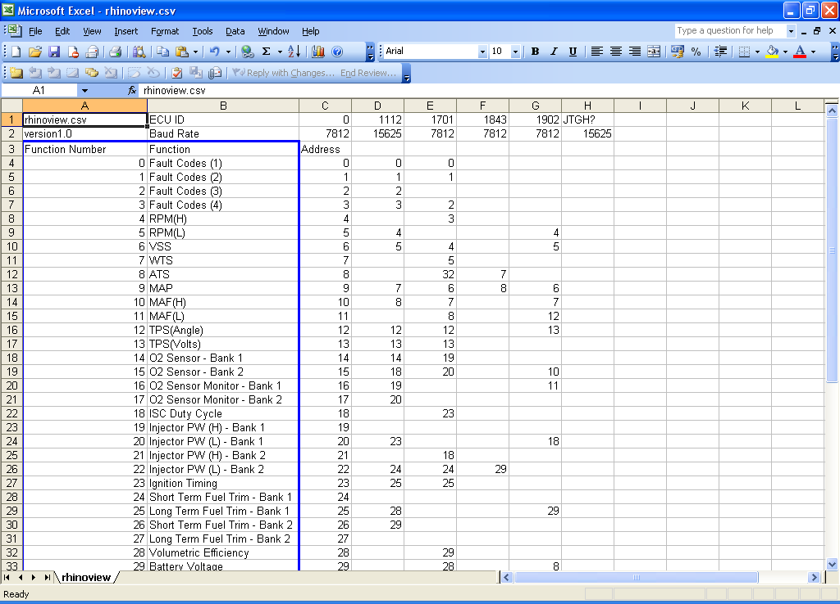

ECU Identification Numbers
Each ECU has its own embedded Identification String, this ID string is returned by the ECU and displayed in the status bar on of the Rhinoview dashboard.

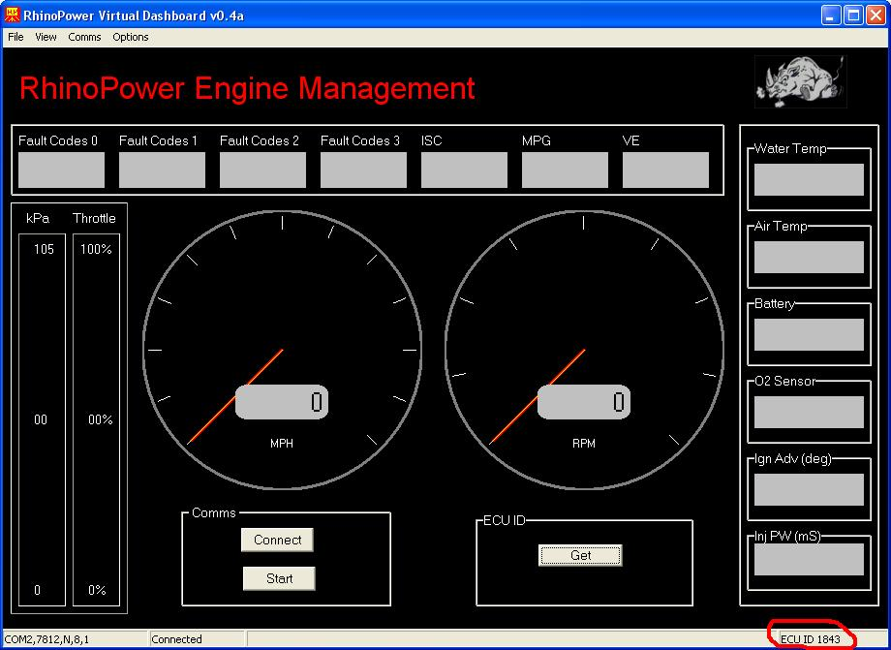

Data for each ECU is stored in columns with the ECUID at the top of each column. New ECU IDs can be added by adding a new column with the ID number at the top. On the line below this the Baud rate should be entered.

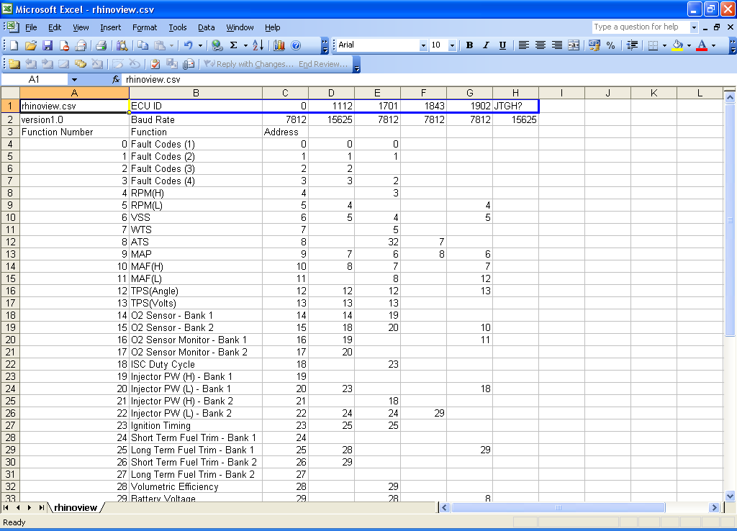

Address Mapping
Referring to the screen capture below, column C contains the address, for each address the function number for that address should be filled in. If the address is not known then the cell can be left blank.

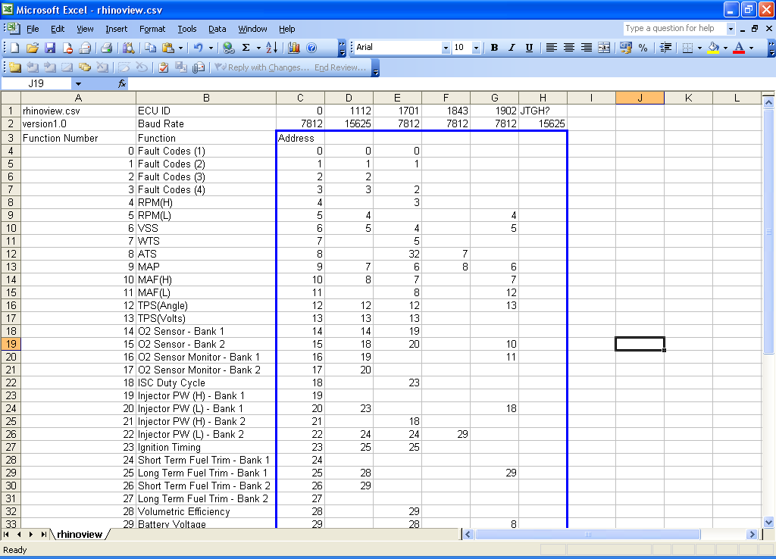

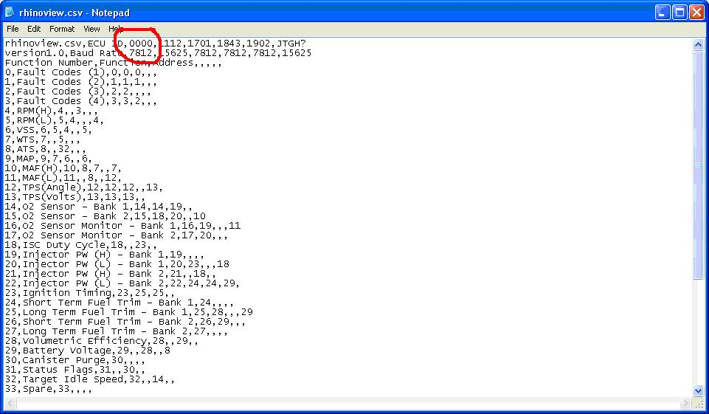

Constant Values

There are a number of scaling factors that must be completed to ensure that Rhinoview functions correctly, these are including under constants. The value is the number that the data returned by the ECU must be multiplied by to give the correct reading.

For Example: At 1000rpm a 1112 ECU returns a value of 250. The scaling factor is therefore 4 so 250 * 4 = 1000.

