Using MGTEK MiniIDE with TASM
MiniIDE is a Windows based GUI that was designed for use with a 68HC11 or 68HC12 microcontroller, this document shows how to set it up to work with the Telemark assembler (TASM) to manipulate code for the 76xxx/MH6xxx series processors. MiniIDE provides coloured syntax highlighting that will work on the majority of the instructions that the 76xxx processor uses.
The Telemark assembler is a Win32 application and will work on Windows machines up to and including Windows 7 (probably Windows 8 as well).
MiniIDE can be downloaded from here:
http://www.mgtek.com/miniide/
TASM can be downloaded here:
http://home.comcast.net/~tasm/
To use additional opcodes in the 76xxx instruction set you will also need the opcode definition file tasm6111.tab which can be downloaded from the files section of the DSM-ECU Yahoo group
http://autos.groups.yahoo.com/group/dsm-ecu/?yguid=179580272
I set up a directory called C:/tasm and placed all the TASM files and the assembly listings there and then installed MiniIDE. When run it looks like this:
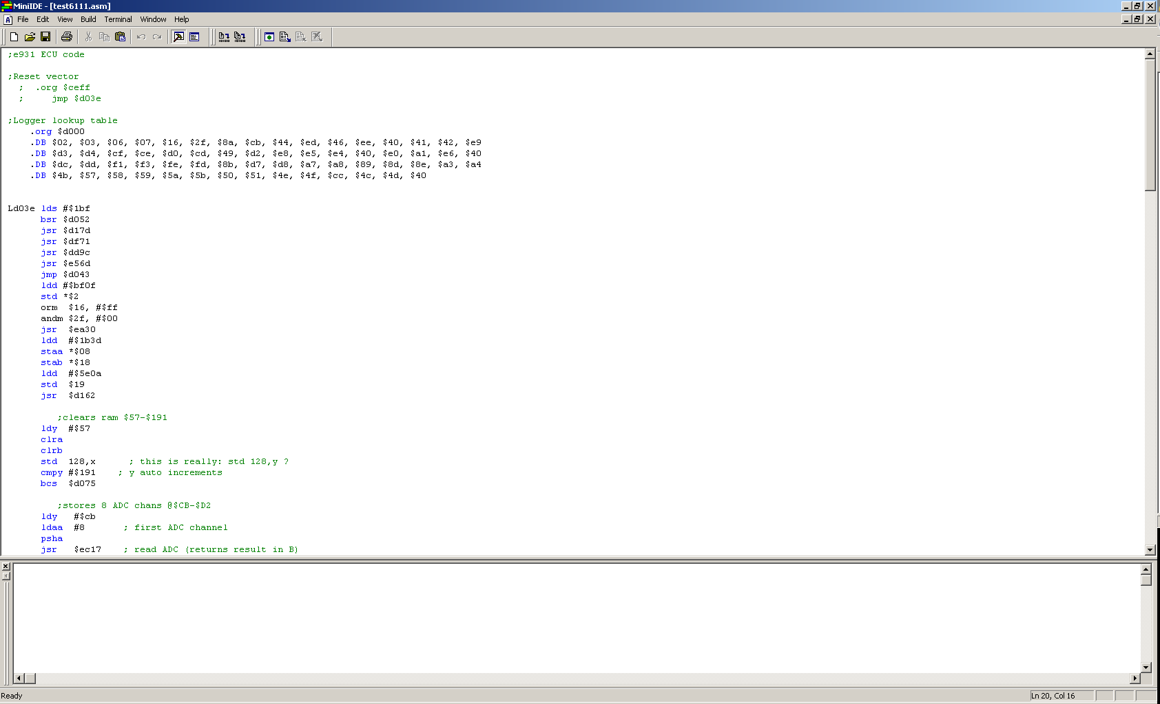

Now set up assembler by selecting Build->Options and enter TASM as the tool set
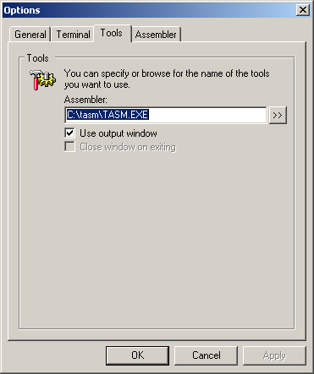
Under Assembler the command line options can be entered, in this case I’m telling the assembler to use the 6111 op-code table, ignore case in labels, use the extended instruction set and generate a binary output.
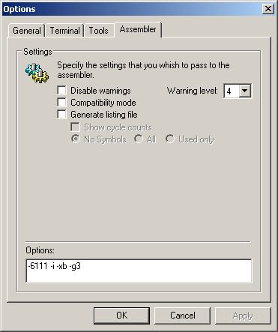

To assemble a file select Build -> build filename. The DOS ouput messages are diverted to the message window in the MiniIDE as shown below:
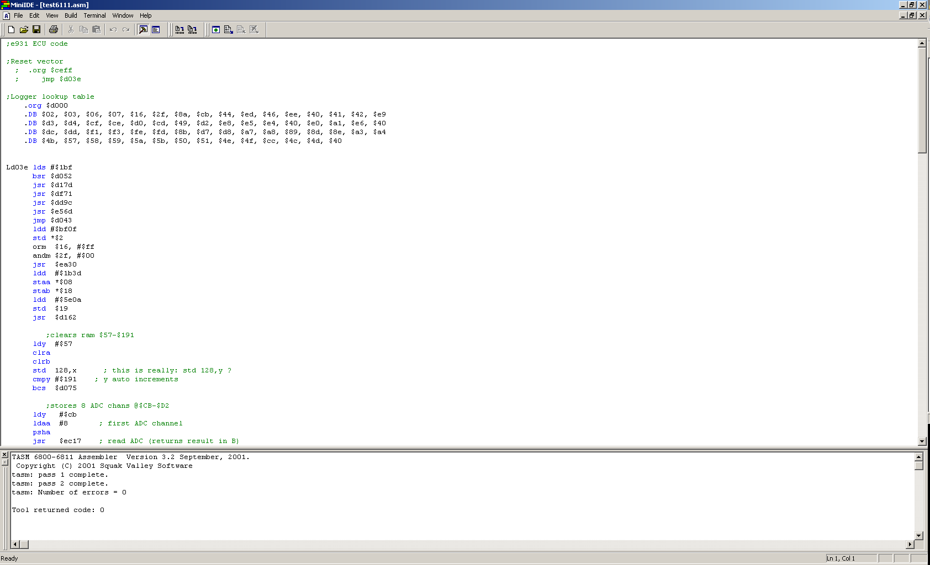

Using Motorola Syntax
To make TASM accept source code that is more like Motorola source code you need to include the assembler directive #inc “moto.h”

If you have any feedback on this document please email me:
james.holland at rhinopower.org

